**ANALYSIS PERFORMANCE AND EEFICIENCY OF THE RADISSON HOTELS USING DATA VISUALIZATION TECHNIQUES**

1. **INTRODUCTION:**

**Radisson Hotels** is an international hotel chain headquartered in the [United States](https://en.wikipedia.org/wiki/United_States). A diuvision of the [Radisson Hotel Group](https://en.wikipedia.org/wiki/Radisson_Hotel_Group), it operates the brands [Radisson Blu](https://en.wikipedia.org/wiki/Radisson_Blu), [Radisson Red](https://en.wikipedia.org/wiki/Radisson_Red), [Radisson Collection](https://en.wikipedia.org/wiki/Radisson_Collection), [Country Inn & Suites](https://en.wikipedia.org/wiki/Country_Inn_%26_Suites), and [Park Inn by Radisson](https://en.wikipedia.org/wiki/Park_Inn_by_Radisson), among others . Radisson Collection was formerly known as Quorvus Collection from 2014 to 2018. Quorvus Collection was introduced in 2014 as a luxury brand. The first hotel of former Rezidor Hotel Group in Copenhagen, was converted to use Radisson Collection brand.

1. **OVERVIEW:**

At Radisson Hotel Group we strive to be the first choice in the mind of guests, owners and talent. In our journey to achieve this, we practice strong beliefs and actions that respect the diversity of people, the community, ethics and the planet. The essence of Radisson Blu is reflected in every aspect of who we are and what we do. We provide unparalleled service, comfort, and style while creating meaningful and memorable experiences. By paying close attention to the small details that make a big difference, we inspire unforgettable experiences with every stay.

1. **PURPOSE:**

At Radisson Hotel Group we strive to be the first choice in the mind of guests, owners and talent. In our journey to achieve this, we practice strong beliefs and actions that respect the diversity of people, the community, ethics and the planet. Essentially, classification systems serve the same main and vital purpose: to provide reliable information about a product that is often purchased, the hotel.

1. **PROBLEM DESINATION AND DESIGN THINKING:**

**EMPATHY MAP**

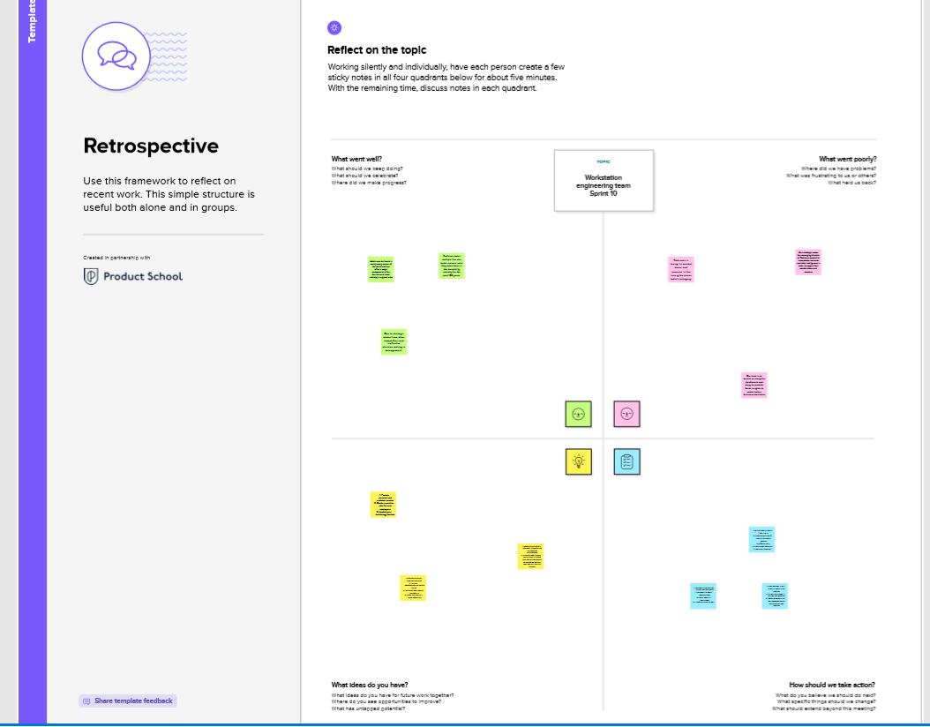

**BRAINSTROMING**

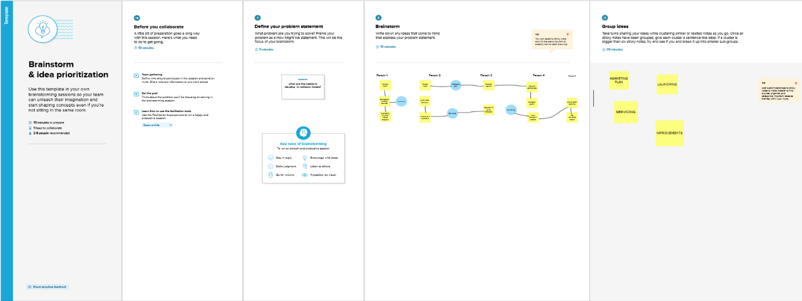

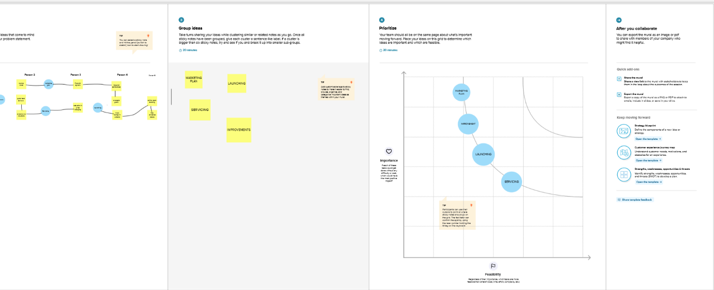

1. **RESULT:**

**DASHBOARD**

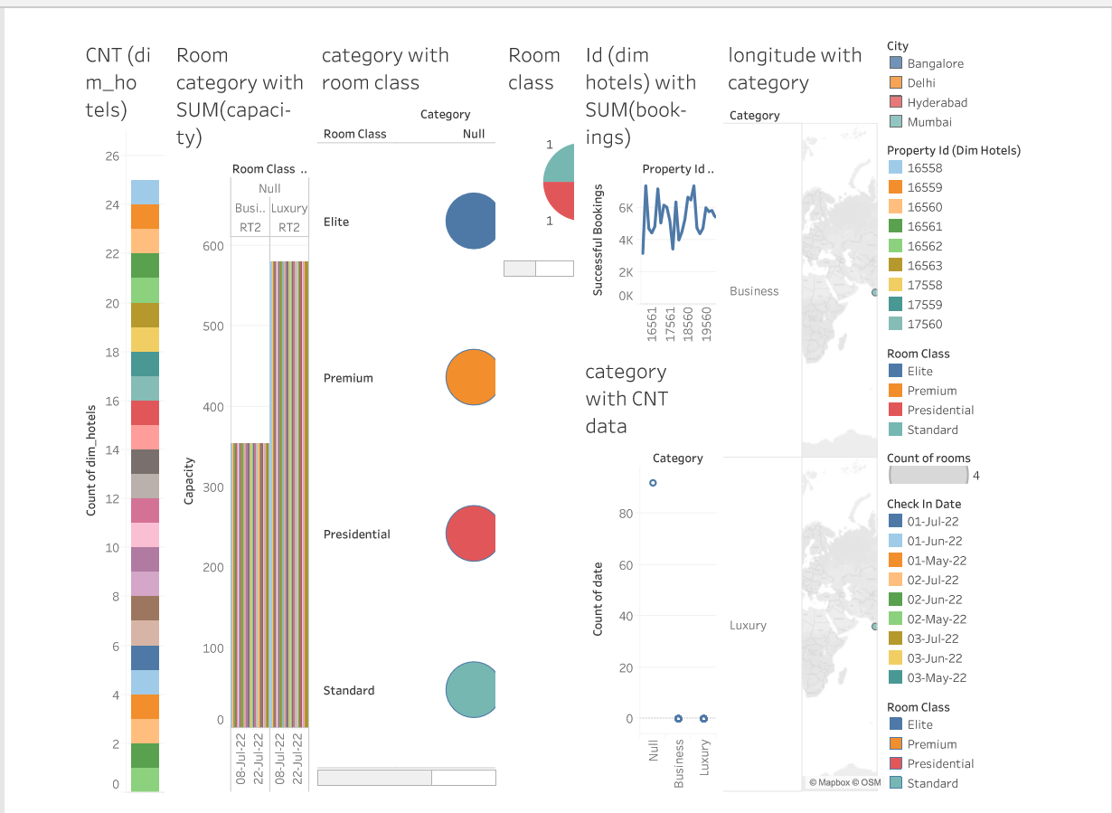

**STORY**

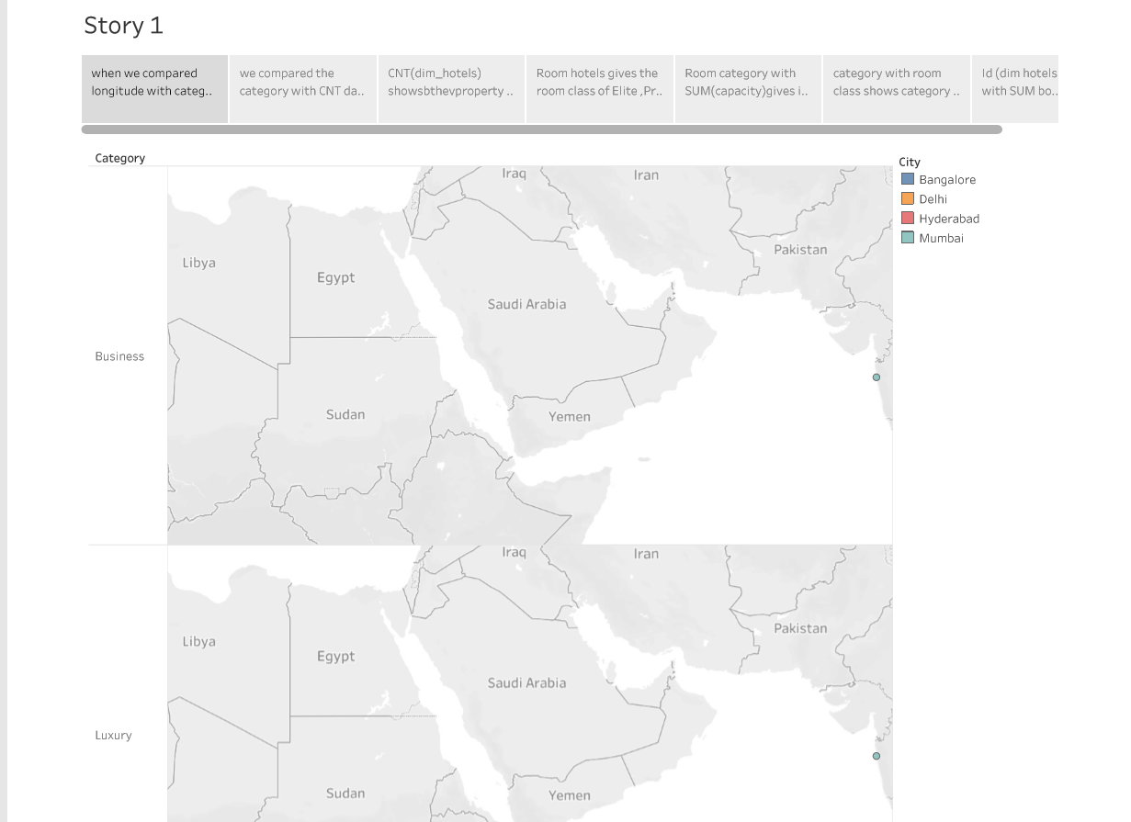

1. **ADVANTAGES:**

* Free upgrades for the guest's next visit.
* Complimentary food and beverage items at the hotel.
* Exclusive discounts on future stays.
* Earn 20 points per $1 spent on eligible stays
* Hotels are usually located in the city center, so you don’t have to waste time traveling to and from your accommodation.

1. **DISADVANTAGES:**

* Hotels can be more expensive than other forms of accommodations as well.
* Rooms rarely have a kitchen to cook your own meals, forcing you to go out for meals and spend more money on your trip.
* Less flexibility should you need to take unexpected time off or otherwise modify your schedule without significant notice.

1. **APPLICATIONS:**

* To ensure prompt response from hotel management staff, applicants should ensure all information provided on hiring materials remains accurate and up-to-date.
* Guests must present either government identification or military orders on arrival for check-in.
* Photo gallery.
* Map.
* Price details.
* Basic information (address, stars, etc.)
* Hotel facilities & policies.

1. **CONCLUSION:**

The primary purpose of hotels is to provide travelers with shelter, food, refreshment, and similar services and goods, offering on a commercial basis things that are customarily furnished within households but unavailable to people on a journey away from home. The solutions given for some problems in the hotels .

1. **FUTURE SCOPE:**

* the hotel management industry has huge growth potential in the near future
* The demand for smart and skilled professionals in this industry is growing at a fast pace, not only in India but also worldwide.
* There is a dire need for skilled and retainable professionals.

1. **APPENDIX**

**Source code:**

 <div class="section-title">

          <h2>dashboard</h2>

          <div class='tableauPlaceholder' id='viz1682357612466' style='position: relative'><noscript><a href='#'><img alt='Dashboard 2 ' src='https:&#47;&#47;public.tableau.com&#47;static&#47;images&#47;Ra&#47;RaddisonhotelsDashboard&#47;Dashboard2&#47;1_rss.png' style='border: none' /></a></noscript><object class='tableauViz'  style='display:none;'><param name='host_url' value='https%3A%2F%2Fpublic.tableau.com%2F' /> <param name='embed_code_version' value='3' /> <param name='site_root' value='' /><param name='name' value='RaddisonhotelsDashboard&#47;Dashboard2' /><param name='tabs' value='no' /><param name='toolbar' value='yes' /><param name='static_image' value='https:&#47;&#47;public.tableau.com&#47;static&#47;images&#47;Ra&#47;RaddisonhotelsDashboard&#47;Dashboard2&#47;1.png' /> <param name='animate_transition' value='yes' /><param name='display_static_image' value='yes' /><param name='display_spinner' value='yes' /><param name='display_overlay' value='yes' /><param name='display_count' value='yes' /><param name='language' value='en-US' /></object></div>                <script type='text/javascript'>                    var divElement = document.getElementById('viz1682357612466');                    var vizElement = divElement.getElementsByTagName('object')[0];                    if ( divElement.offsetWidth > 800 ) { vizElement.style.width='1000px';vizElement.style.height='827px';} else if ( divElement.offsetWidth > 500 ) { vizElement.style.width='1000px';vizElement.style.height='827px';} else { vizElement.style.width='100%';vizElement.style.height='2477px';}                     var scriptElement = document.createElement('script');                    scriptElement.src = 'https://public.tableau.com/javascripts/api/viz_v1.js';                    vizElement.parentNode.insertBefore(scriptElement, vizElement);                </script>

        </div>

 <div class="section-title">

          <h2>story</h2

            <div class='tableauPlaceholder' id='viz1682358270550' style='position: relative'><noscript><a href='#'><img alt='Story 1 ' src='https:&#47;&#47;public.tableau.com&#47;static&#47;images&#47;Ra&#47;Raddisonhotelsstory&#47;Story1&#47;1_rss.png' style='border: none' /></a></noscript><object class='tableauViz'  style='display:none;'><param name='host_url' value='https%3A%2F%2Fpublic.tableau.com%2F' /> <param name='embed_code_version' value='3' /> <param name='site_root' value='' /><param name='name' value='Raddisonhotelsstory&#47;Story1' /><param name='tabs' value='no' /><param name='toolbar' value='yes' /><param name='static_image' value='https:&#47;&#47;public.tableau.com&#47;static&#47;images&#47;Ra&#47;Raddisonhotelsstory&#47;Story1&#47;1.png' /> <param name='animate_transition' value='yes' /><param name='display_static_image' value='yes' /><param name='display_spinner' value='yes' /><param name='display_overlay' value='yes' /><param name='display_count' value='yes' /><param name='language' value='en-US' /></object></div>                <script type='text/javascript'>                    var divElement = document.getElementById('viz1682358270550');                    var vizElement = divElement.getElementsByTagName('object')[0];                    vizElement.style.width='1016px';vizElement.style.height='991px';                    var scriptElement = document.createElement('script');                    scriptElement.src = 'https://public.tableau.com/javascripts/api/viz_v1.js';                    vizElement.parentNode.insertBefore(scriptElement, vizElement);                </script>

        </div>